Down Wind Sports
JR. Mountain bike team

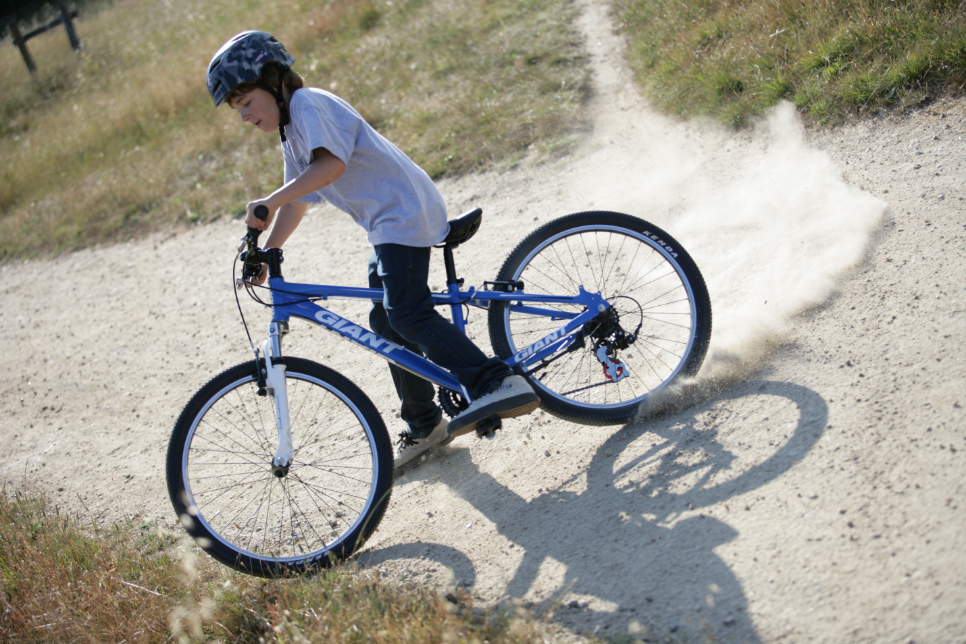

Join today!
Down Wind Sports
JR. Mountain bike team

Become a member Of the
Down Wind Sports
Jr. Mountain Bike Team
to learn the skills to
tackle the trail,
Tackle the road or
whatever challenge
is in your way!

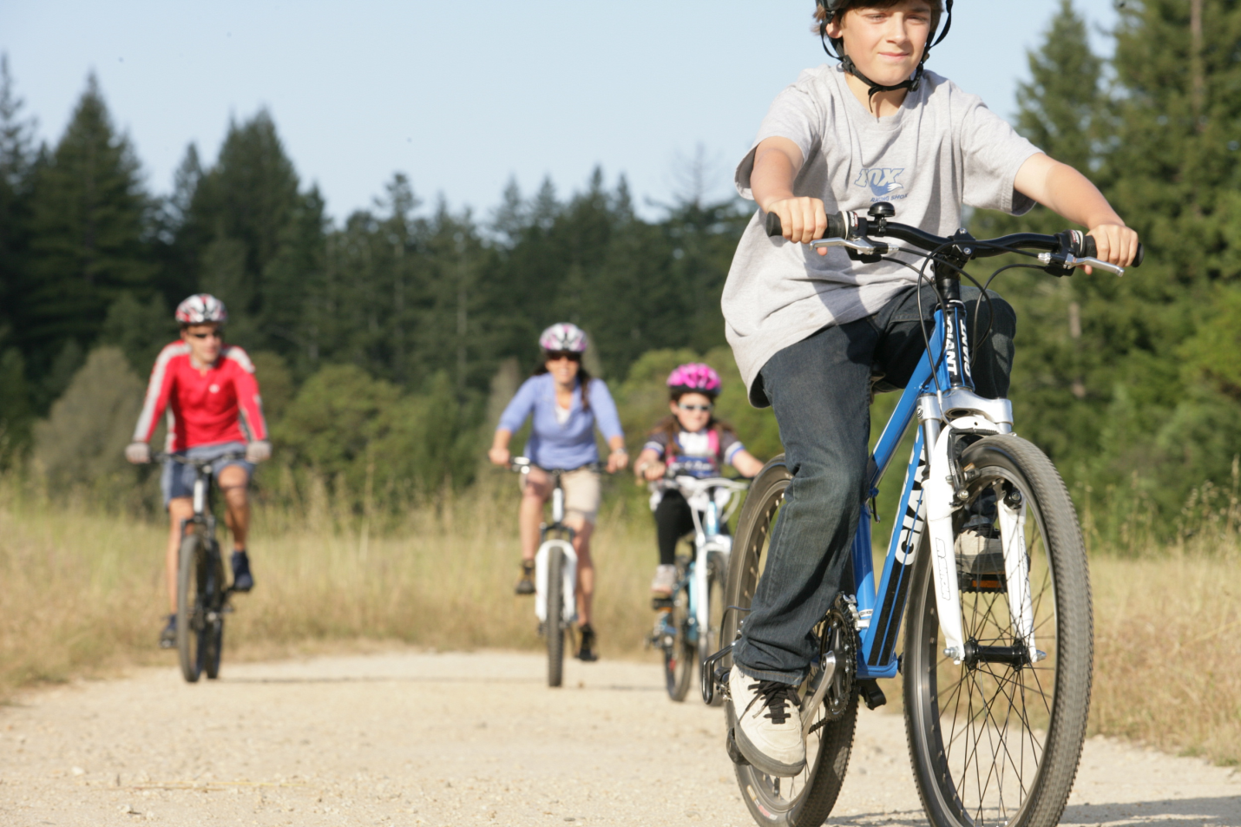

The team will meet weekly beginning on June 16th.
We will meet each Tuesday morning at 9 AM at Tourist Park.

Our riders can expect to have a brief lesson each week discussing maintenance, nutrition, racing and other aspects of riding. We will then take to the woods in our ability appropriate groups and ride on mountain bike trails for the duration of the 2 hours. We will ride over logs & rocks, down & up steep hills. We will negotiate challenging corners and different terrain.
Most importantly, we will have FUN!

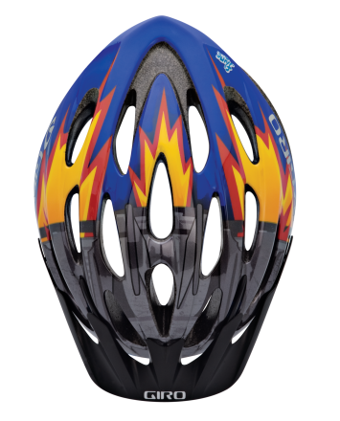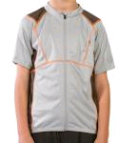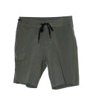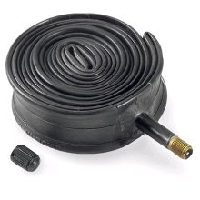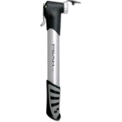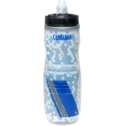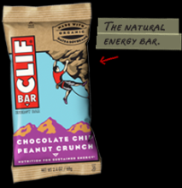
Don’t forget:

Bug spray
& Sunscreen

Breakfast

Biking shorts & jerseys highly recommended

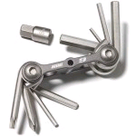 Jr Team 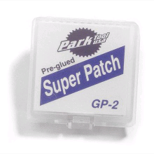Required Equipment 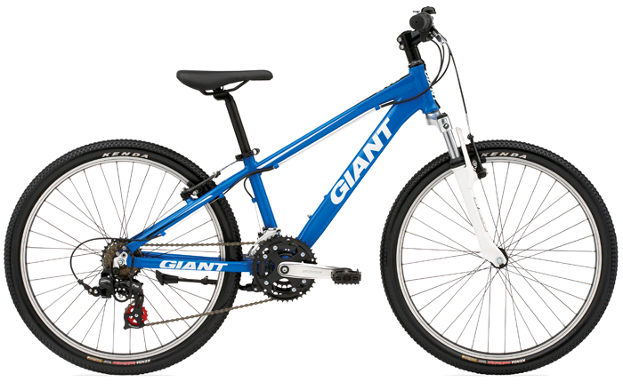
All riders must have a multi-speed bike in good working condition. All riders must bring their bikes to Down Wind Sports for a mechanical evaluation. See instructions for details

Down Wind Sports
JR. Mountain bike team

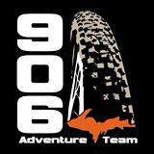

Please read each rule carefully, call Down Wind Sports for more information (226-7112).
1. June 16th Mandatory Meeting. At this meeting each rider is placed on a team after their abilities have been evaluated. It is dangerous to have unevaluated riders on the trails. All riders must be present at the orientation meeting on June 16^{th.} Please speak with a Down Wind Sports Team Coach prior to June 16th if you have any questions.
2. Be on time. We begin each meeting at 9AM at Tourist Park.
3. Be on time to pick up. We finish at 11 AM. Our volunteers have generously donated their time, and have other responsibilities. Please make sure you are on time to pick up your rider, or make sure they know where to go after the ride.
4. Scrapes & Bruises. There will be some scrapes and bruises. We are mountain bike riding
on single track trails in the woods. We will be challenging our abilities each week, and we will fall. Each team coach has a first aid kit and cell phone with them at all times. Practice makes perfect.
5. Weather. We are hearty souls, however riding on wet trails is dangerous to the riders and damaging to the trails. We will not ride if: it is raining, or has rained the night before. If questionable check the Down Wind Sports Facebook Page or call Jeff at home (226-9290).
6. Tools. Age 10 & up: It is important to learn to be self-sufficient in the woods and we will learn to use each of these tools as the weeks go on. Hey, who wants to walk home? The rider will carry the following tools: a patch kit, a spare tube, a pump, an allen wrench set. The following tools are recommended for serious riders also: a power link, a chain tool, & some duct tape.
7. Breakfast. We have learned that nutrition is often the key to success. Please be sure your rider has had a nutritious breakfast. It is dangerous to ride without fuel! We will stop for a snack break and expect riders to have an energy bar, raisins or another snack with them.
8. Coaches. Each team will have at least 2 coaches. One coach will lead, one will follow. The riders are not allowed to pass the lead coach.
9. Parental involvement. We realize that watching your young rider develop is awesome for parents to watch. However, we have found that the riders often do not challenge themselves when a parent is watching. We love to have your support, and always need volunteers. Your help will be best appreciated by riding in a different group than your child. We will help you decide what team you are most suited for.
10. Sunscreen & Bug Spray. Need we say more?
11. Bike Checks. It is important that all riders have a multi- speed bike in good working condition. All riders must bring bikes in for Mechanic Evaluation. A Down Wind Sport’s mechanic will check the bike over during normal business hours, and a tune up may be required. On the trail is not the time to find out that a rider’s brakes don’t stop them or that shifting into an easier gear is not possible.
12. Community Involvement. There are many opportunities for young riders to strut their stuff. We believe in supporting local bike events and encourage the riders to participate in the races. Throughout the summer we will help them to prepare to take their riding to the next level, and challenge themselves.

Waiver of Claims and Release of Liability
Please read the following release carefully and be sure that you understand its contents prior to signing.
The undersigned, in consideration of being permitted to participate in the mountain bike rides as a member of the U.P. Mountain Biking club, a member of I.M.B.A, do acknowledge by my signature below that my participation is voluntary and that I assume full and total responsibility for my safety and well being. I further acknowledge that these rides are a voluntary social gathering and that my participation and safety are my responsibility. I agree to wear a helmet and operate my mountain bike in a safe manner which will not jeopardize the safety of myself or others.
I further acknowledge and fully understand that mountain biking activities may be dangerous and involve risk of serious injury, including permanent disability and death, severe social and economic losses which might result not only of my own actions, inactions or negligence, but the action, inaction or negligence of others, the conditions of the premises or the equipment used. Further, that there may be other risks not known to us or not foreseeable at this time. I further assume all the foregoing risks and accept personal responsibility for the damages following any such injury, permanent disability or death.
I further release, waive, discharge and covenant not to sue Down Wind Sports South, Inc., Keweenaw Mountaineering Inc., or the U.P. Mountain Bike Club, 906 Adventure Team, their respective officers, administrators, directors, agents, employees, volunteers, sponsors, or land owners from demands, losses or damages on account of any injury, including death or damage to property, caused in whole or part by negligence otherwise during said mountain bike rides.
I/we have read the above waiver and release and sign it voluntarily. I further agree that if I am signing as a parent and/or legal guardian, I will instruct the minor participants to riding and acknowledge that I am totally and completely responsible for their actions. I further acknowledge that this release will apply for all rides during the current season.

Rider Name:___________ Rider Signature:______________
Address:__________________________________________
Phone:__________ Email:____________ Age:___________

Parent or Legal Guardian:___________________________
Parent Signature:__________________________________
Parent Contact # during rides:________________________

Let your journey begin

Down Wind Sports is pleased to
announce its family plan!

Purchase 2 or more bikes for the family to earn a
$40 gift card toward
Biking accessories!
.

-

